MACH4METAL

metalworking machinery
Transito 21
6909 DA BABBERICH Netherlands
Tel. +31 (0)316-247123

Bank No : 66.52.13.883
IBAN : NL33 INGB 0665 2138 83
BIC : INGBNL2A

COMAC 3055 Profile bender
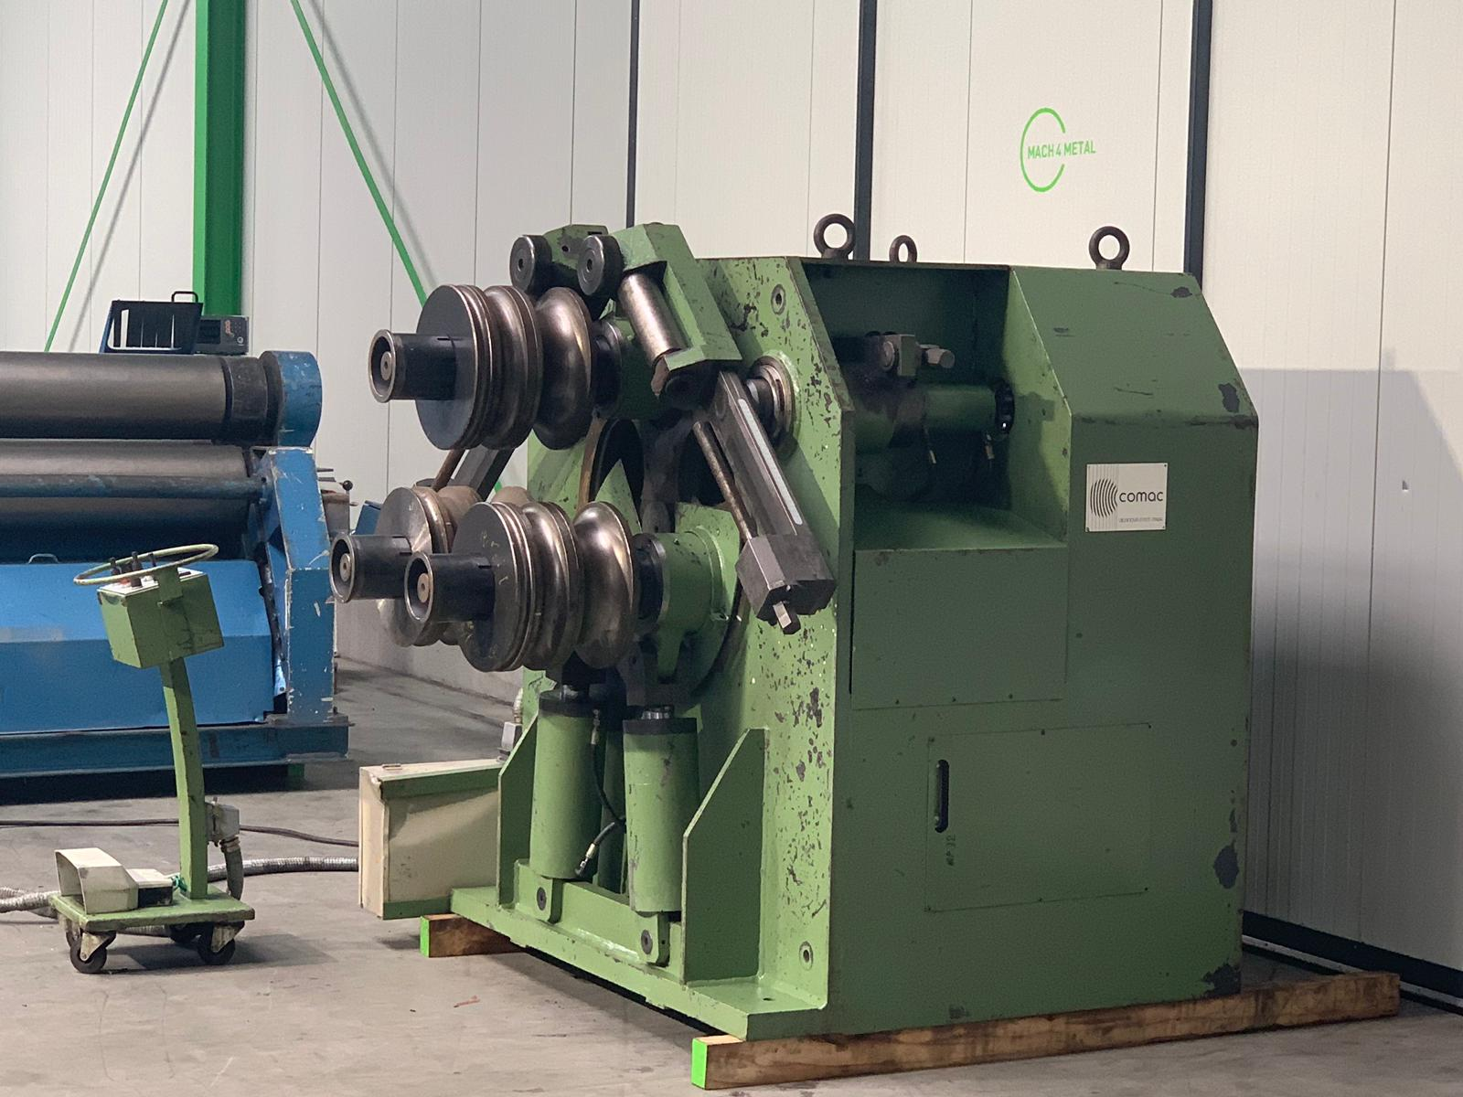
- Make : COMAC ITALIA
- Typ : 3055 HV
- YOP : 1991
- Serial : M 1470

- Schaft Ø : 120 mm
- Rol Ø : 400 mm
- Bending moment : 33 cm³

- Min. bending speed : 2.5 M/Min
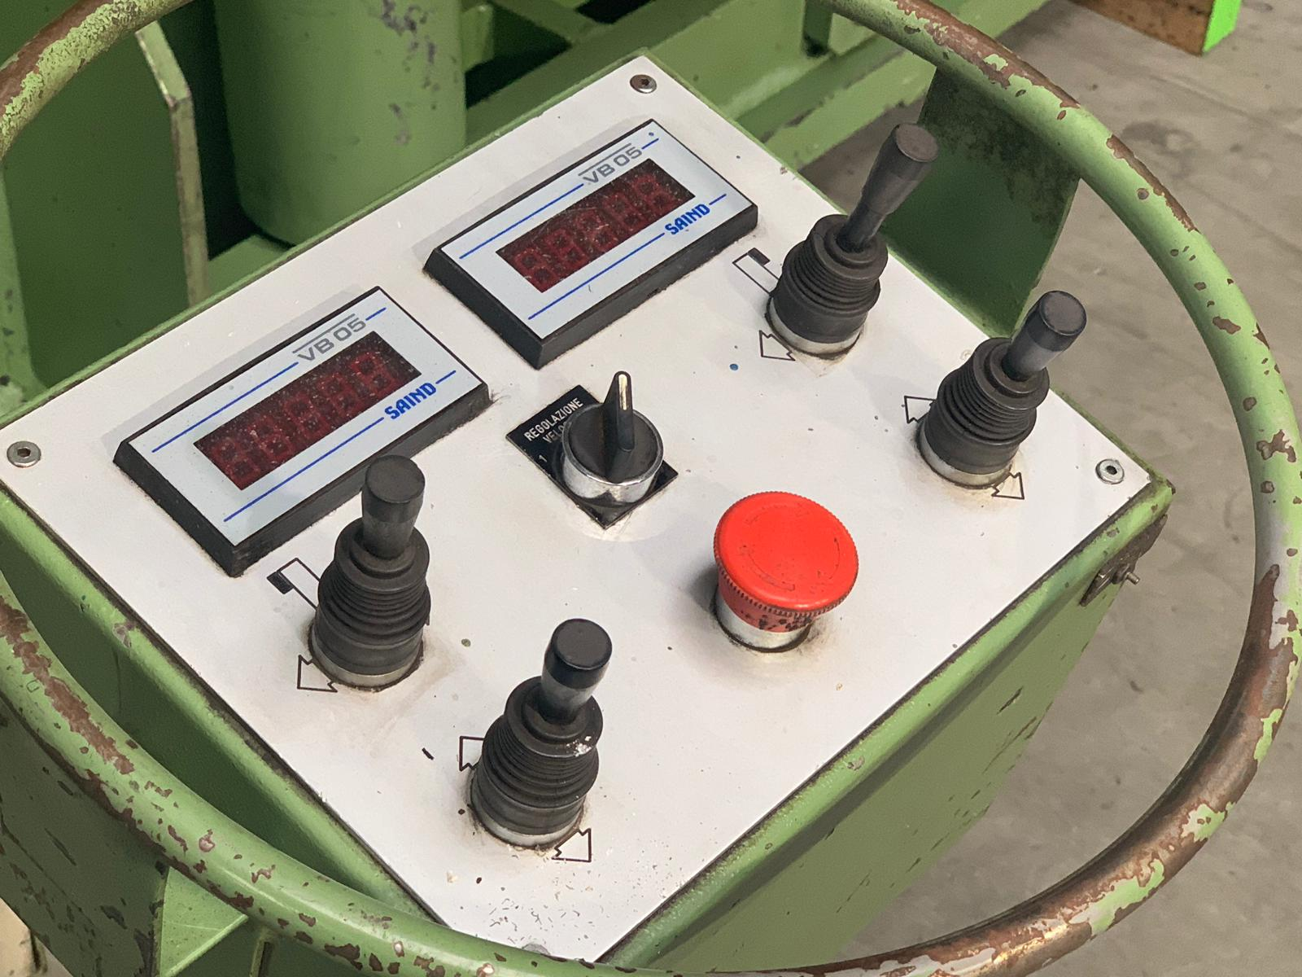
- Max. bending speed : 7.5 M/Min
- Motor power : 15 kW

- Capacity:

- Flatt 125 x 25 x Ø 1300
- Square 80 x 80 x Ø 1000
- I 240 x 106 x Ø 1500
- H 120 x 114 x Ø 2500
- Tube 139 x 5 x Ø 1300
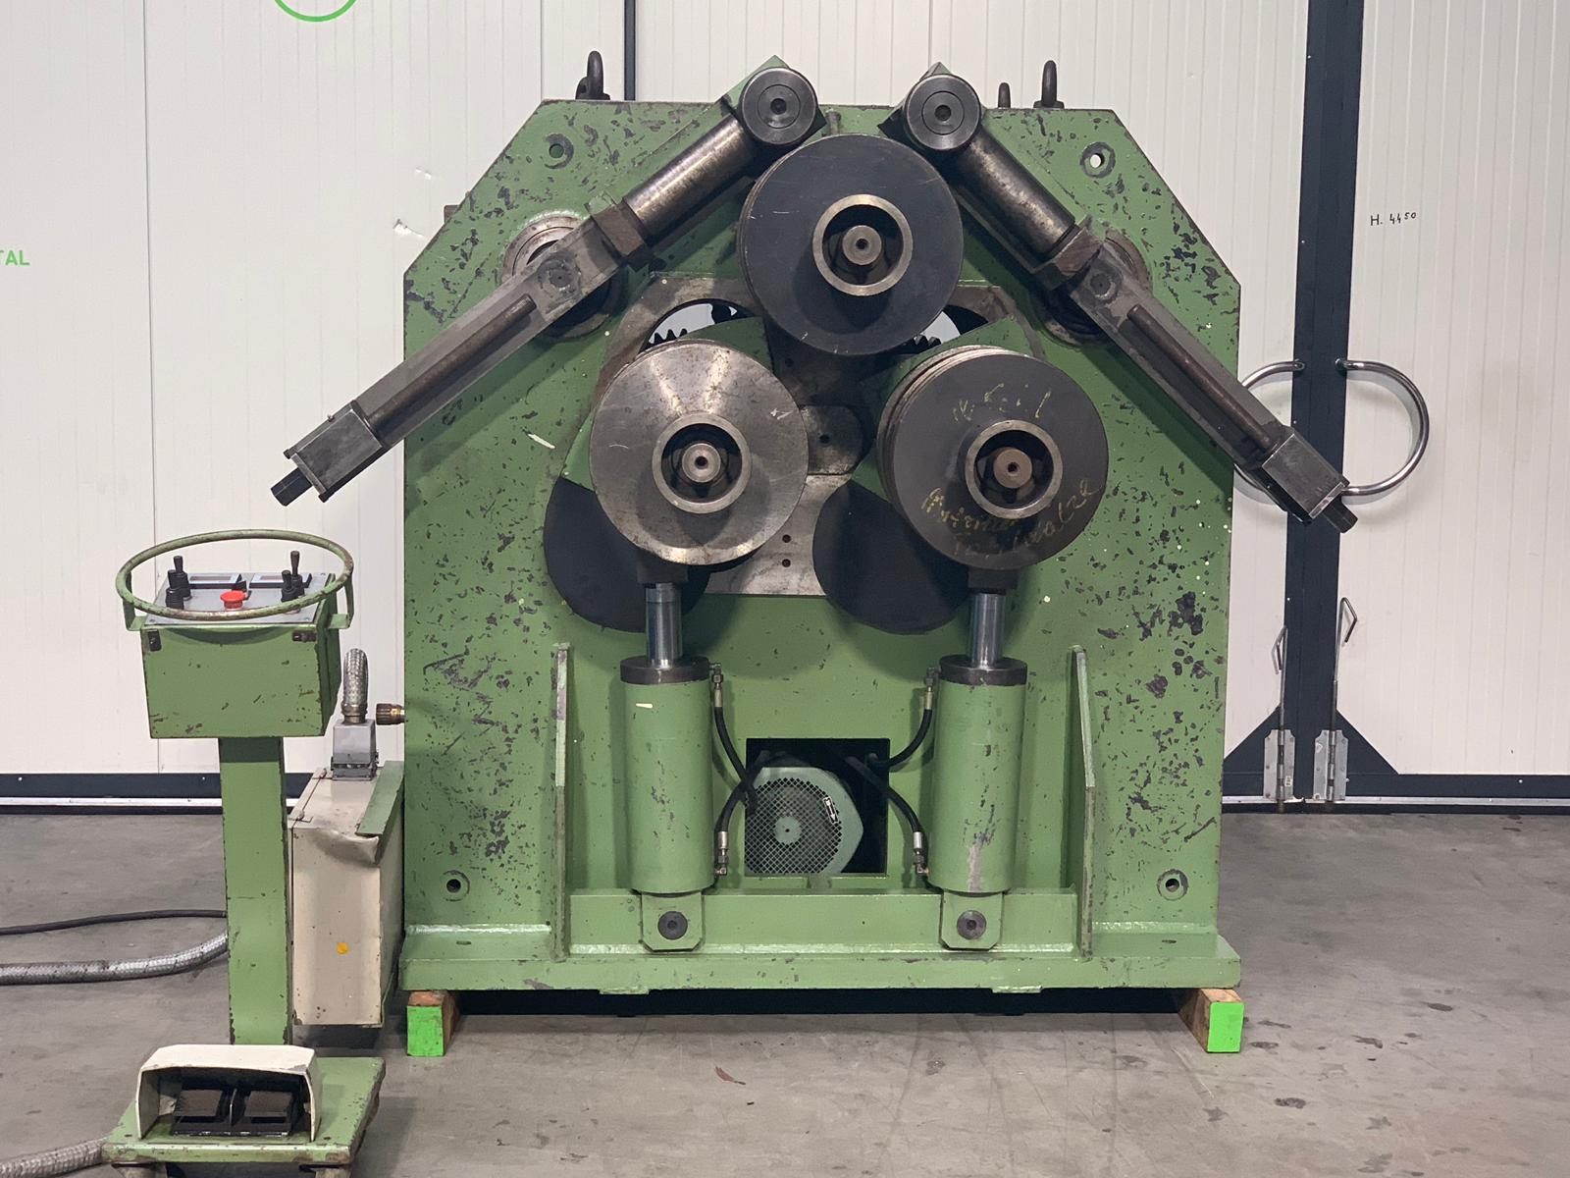
- Length :
- Width :
- Height :
- Weight :

- Digital readout pos. rolls
- Central lubrication
- Guide & pressure rolls
- Can be used in horizontal & vertical position

- Universal set rolls for profile
- Pipe rolls for Ø 140 / 125 / 75 / 60 / 50 / 35 / 32 / 25

Please Note: The above information has been obtained to the best of our ability and belief from, and from the manufacturers where possible. It is given in good faith, but its accuracy can not be guaranteed. Accordingly, it will not form a representation or constitute contractual terms. We advise you to check any vital details!

